**NAME**

**REG NUMBER**

**TOPIC:** What factors affect chief executive officer salaries?

**ABSTRACT**

Workforce dynamics come in many forms. A typical company deals with so many factors, some of which have endless needs form day to day. Within an organization structure there are different types of functional departments such as, the Human Resource, Information technology, Supply chain and procurement, Sales and Marketing, Customer service and Front office. At the top of all these are the management staff.

Whereas the management of most of these organizations differ from one company to the other, ideally most of them follow at least one method of leadership style. The most common being the top down approach of management where the management at the top is headed by the founder, then board of directors and finally other directors and line managers to employees who are at the bottom lower domain. Further, different companies have different methods and techniques of awarding and paying their top leadership.

It’s a common belief that senior employees who are at the top of leadership and management are the most paid and take home high salaries and incomes at the end of every month, get more bonuses and are the most gifted every financial year. Well, this study sought out to identify if some of these issues could be true or not, took down a case by case study review and then articulated the findings and conclusions of these studies.

**Introduction:**

While looking at both the private and public sector, one can almost argue that the top management is and CEOs of certain companies are the most valued. Partially, this is true, but also untrue to a greater extent and some of the CEOs leading some of the successful companies are the unhappy ones, D’Ambrosio et al (2020). Psychologically, money has been ranked as not being the best item in making people happy. It’s also true that one can have high salaries yet they are still unhappy.

Companies will also only pay higher salaries if they company is doing well, and that is why a bigger chunk of the stress falls on the back of the Chief executive officers and top tier management. If the company fails, they are also considered to have failed and have to go home. According to Singh et al (2019), In lieu of this, most companies whether in the private sector or public sector are considering a number of factors to cushion their top management from falling into the traps of poor performance and ensure that they can only give their best since they are the eyes of the company. They relay and communicate the vision and roadmap missions of the company on behalf of the shareholders. Forming the part of this study and research, one of the questions that the researcher aims to answer is how they aim to achieve this.

**Background study and problem statement.**

Money as a tool of economic production together with labor have been put on test in so many cases to help determine how and why successful companies meet their target objectives and goals. The very first item that rings into the job seekers mind whenever they want to jump from one company to another is always the financial remuneration and package.

Whereas most companies do not put this as part of their checklist, some of them consider items like healthcare and insurance for the top CEOS. So one would ask, what makes bright the difference in salaries and remuneration of top management in different companies across the globe? To answer, let’s discuss some of the factors that makes different employees earn varyingly from other employees in other companies;

Current market share of a company is a contributing factor. A company that has a greater monopoly of the market share makes more profit and is able to pay its employees well. In turn, good financial performance of a company is attributed to the fact the chief executive officers made good decissions that drove the business into profits.

Organizational reputation. Some companies their employees well because they are known for it. The United Nations for example has been known to pay its staff at international scope and levels, the pay grade and structure beats what most of other employees in developing nation earn.

Age of the company in business. It has been known for long that employees who are part of startup companies will earn slightly different from their counterparts who have been in organizations that have existed for quite a while.

Type of organization. It may be true that government staff are well funded and have a consistent rate of pay regardless of the department. This is untrue for most of the private sector companies that may only pay lower than the expected since private companies are prone to a lot of factors in the economy that can affect their performance.

This study is significant in evaluating the causal factors and variations in salaries between CEOs of companies and the factors affecting such salaries.

**Project Aims and objectives**

The researcher seeks to establish the following aims and objectives in this study:

1. To establish the relationship between employee job satisfaction and amount of salary
2. To establish the relationship between CEO salaries and the tape of companies they work in
3. To establish the relationship between company type and the CEO salaries
4. To establish the relationship between the company location and their CEO salaries

**Literature review**

According to Chaudhry et al (2011), salary satisfaction affects the rate of employee involvement in a job and the overall satisfaction and motivation derived form the same job. Their research and study also revealed that this feeling was true among employees in both in the public and private sector. In order to cover the gaps create between employ pays and the satisfaction and morale derived form their jobs, this particular study suggested the review and scaling go the different employ rates.

In another study done by Andersen et al (2012), a review of compensation packages among employees in the public could help motivate employees further to remain motivated and increase their productivity output. The finding from this study indicated that in order to improve public service output among employees, then there was need to attract employees with the largest public service motivation, based on the reviewed models of compensation packages.

In a study done by Henderson et al (2001), also illustrated that team coordination and management among CEOs of top companies was directly relational to the pay gap among CEOs, the larger the pay gap, the less the coordination among top management teams and the vice versa is true.

**Project Methodology and experimentation**

**Data description**

This study is based on the dataset that is acquired by the researcher and contains up to a total of 209 values that cut across different global companies. The data dataset contains a total of 12 variable columns that were identified by the researcher and they include ; salary, hourly rate, monthly sales, return on investment (ROI), monthly index performance , other employee packages market with 0 for yes and 1 for No, industry type marked with 0 for private and 1 for civil service, funded marked with 0 for yes and 1 for No, experience of the manager, education level of the manager, tax category for the role in that country and finally gender of the staff CEO.

The data was first wrangled and cleaned to remove any spaces, unnecessary negative values, outbound values or really huge numbers, ambiguous inputs by the interviewee and finally null values in some rows. This enabled the researcher to come with a clean consistent dataset that was now ready for analysis. Before, the analysis, the researcher set aside a control experiment with the expected common objectives and only shifted a little the values and variables a little to see what would be the results, which shall be conducted in the next topic under findings. The dependent variable in this case was the salary, against which other independent t variables like age, company performance and education came in.

**Data analysis and presentation**

The researcher used the Python Spyder IDE for data analysis. A simple reading of the CSV dataset from the IDE showed the data;

import pandas as pd

df = pd.read_csv (r'dataset.csv')

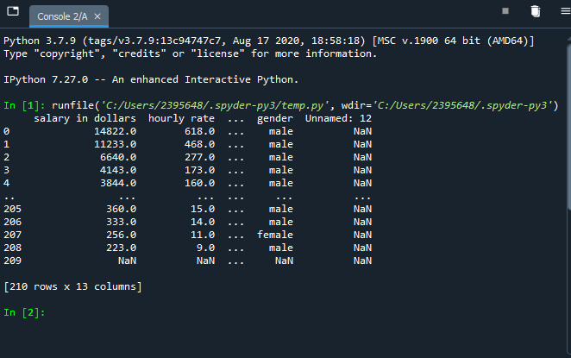

If we proceed to calculate the measure of central tendencies from this dataset we get the following output:

import pandas as pd

df = pd.read_csv (r'dataset.csv')

# Maesuring central tendencies

mean1 = df['salary in dollars'].mean()

sum1 = df['salary in dollars'].sum()

max1 = df['salary in dollars'].max()

min1 = df['salary in dollars'].min()

count1 = df['salary in dollars'].count()

median1 = df['salary in dollars'].median()

std1 = df['salary in dollars'].std()

var1 = df['salary in dollars'].var()

# Followed by a group by

groupby_sum1 = df.groupby(['gender']).sum()

groupby_count1 = df.groupby(['gender']).count()

# Print first values

print ('Mean salary: ' + str(mean1))

print ('Sum of salaries: ' + str(sum1))

print ('Max salary: ' + str(max1))

print ('Min salary: ' + str(min1))

print ('Count of salaries: ' + str(count1))

print ('Median salary: ' + str(median1))

print ('Std of salaries: ' + str(std1))

print ('Var of salaries: ' + str(var1))

# Print second group of values

print ('Sum of values, grouped by the Gender: ' + str(groupby_sum1))

print ('Count of values, grouped by the Gender: ' + str(groupby_count1))

**Observations:**

-There were more males than females as CEOs in most companies

-Males earned a higher salary than their counterparts

A simple plot of the salary incomes of some of the staff and their education levels is as shown below;

import pandas as pd

df = pd.read_csv (r'education.csv')

df.plot(x = 'salary in dollars', y='education', kind = 'scatter')

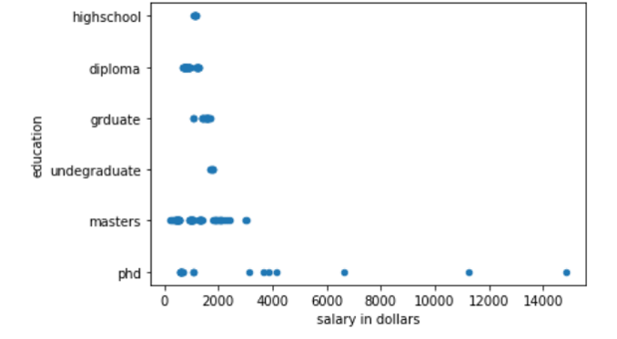

**Observations:**

-There are more CEOs with a master’s degree earning between 1.5K to 3.5K in salaries per month

-Very few PhD holders are earning above 10k in monthly salaries

Another analyses of salary against gender produced the following:

import pandas as pd

df = pd.read_csv (r'gender.csv')

print(df)

df.plot(x = 'salary in dollars', y='gender', kind = 'bar')

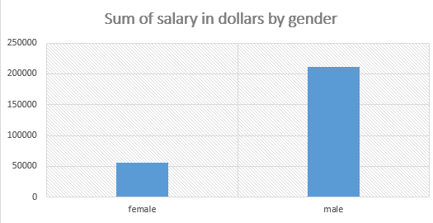

**Measuring covariance relationships**

Given the measurable variable attributes of salary and company return on investments, from the dataset, a covariance relationship was established as follows:

import pandas as pd

import matplotlib.pyplot as plt

df = pd.read_csv (r'Roi.csv')

print(df)

plt.scatter(df['ROI'], df['salary in dollars'])

plt.xlabel('ROI')

plt.ylabel('salary in dollars')

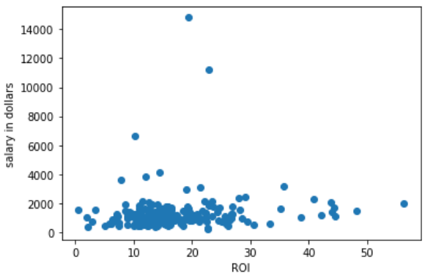

**Observation:**

The analyses revealed that there was no direct relationship between a company’s return on investments and the amount of salary that the CEOs earned, the distribution between high, medium and low ROI was random and scattered, making no meaningful statistical observations, contrary towards would be expected that campiness that have higher ROI have also exhibit higher salaries among top management and vice versa.

**Conclusions and recommendations for future research**

From the study conducted, it can be consulted that organisations pay their CEOs depending on a number of factors such as age, experience, ROI, education and gender. That there are more male CEOs than females. Graduate education could earn one a job as a CEO and that there is no direct relationship between a company’s return on investment and the amount of salary to pay their CEOs. Future researchers could take this study higher by trying to establish the external organisational factors that affect chief officer salaries in organisations.

**REFERENCES**

Chaudhry, Muhammad Shahzad, et al. "Exploring the relationship between salary satisfaction and job satisfaction: A comparison of public and private sector organizations." *The Journal of Commerce* 3.4 (2011): 1.

Andersen, Lotte Bøgh, et al. "Attracting public service motivated employees: How to design compensation packages." *International Review of Administrative Sciences* 78.4 (2012): 615-641.

Henderson, Andrew D., and James W. Fredrickson. "Top management team coordination needs and the CEO pay gap: A competitive test of economic and behavioral views." *Academy of Management Journal* 44.1 (2001): 96-117.

D’Ambrosio, Conchita, Markus Jäntti, and Anthony Lepinteur. "Money and happiness: Income, wealth and subjective well-being." *Social Indicators Research* 148.1 (2020): 47-66.

Singh, Sanjay Kumar, et al. "Top management knowledge value, knowledge sharing practices, open innovation and organizational performance." *Journal of Business Research* (2019).

.